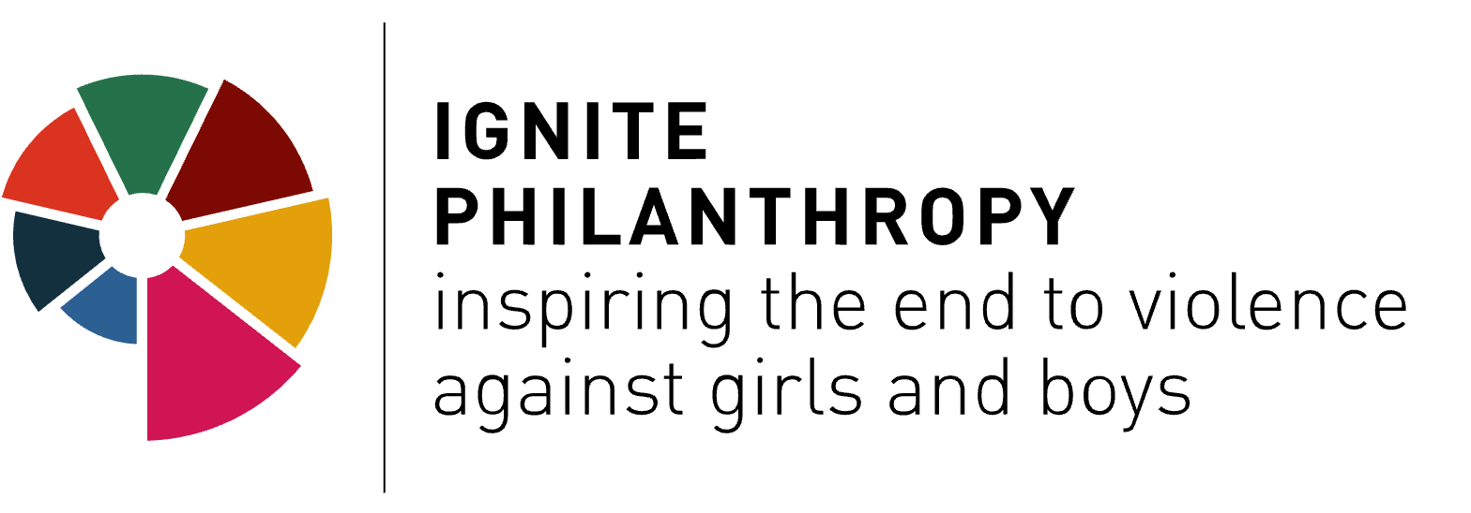
I General information

- Name of organization

- Implementing country for the grant :

- Primary contact person
    - Name and Surname:
    - Country of residence:
    - Email:
    - Phone/Mobile Number

- Secondary contact person
    - Name and Surname:
    - Email:
    - Phone/Mobile Number

- Website/Social networks (if any):

- What is your preferred method of contact? Please indicate if you are using WhatsApp or any other online calls/messaging application:

* The data provided will be solely used for the purpose of application process and we will ensure confidentiality.

II Tell us about your organization

- What type of organization are you:
- Registered organization (association, foundation, network etc)
- Non-registered organization (3 persons at least)

- How long have you been organizing/ working together/ in operation?
- Less than a year
- 1-2 years
- 2-5 years
- 5-10 years
- More than 10 years

- If you are a non-registered organization do you have a partner organization that can support you in receiving a grant? If yes, please provide their name and location. If not, we will reach out to you in due time to provide assistance.

- If you are a non-registered organization how do you resource your actions?

By resourcing we mean any material or immaterial contributions to your work, including volunteering efforts

We suggest that you limit your answer to 300 words, if your story and your language allows

- If you are a registered organization, what is your approximate annual budget over the last 2 years (actual costs of running an organization) ?

6.Tell us the story of how your organization first started organizing in the context of sexual violence against children? What brought you together, how did it develop from an idea to action?

We suggest that you limit your answer to 600 words if your story and your language allow.

7. Tell us about your team. How would you describe them? Do you or other members of staff in your organization, identify as ‘survivors’ or as people with lived experience of childhood sexual violence?

We suggest that you limit your answer to 600 words, if your story and your language allow.

8.How do you embed safety and care into your actions? For example, how do you reduce the risks to your staff/volunteers?

We suggest that you limit your answer to 600 words, if your story and your language allows.

III Describe your work

- Tell us a bit more about your context, community, the issues you are facing or anything related to the background of your organizing that you are comfortable sharing with us.

We suggest that you limit your answer to 600 words if your story and your language allows.

- What past actions is your organization proud of that have contributed to preventing or ending childhood sexual violence?

We are interested in any kind of organizing; even if you just started by talking and planning actions together, it counts and we would love to know more!
We suggest that you limit your answer to 600 words if your story and your language allows.

- Tell us your plan- how would you strengthen and better organize your organization with these funds to achieve your desired impact?
We suggest that you limit your answer to 600 words if your story and your language allows.

4. Will this initiative/grant involve working with minors (individuals under the age of 18). If yes, pls explain.
We suggest that you limit your answer to 600 words if your story and your language allows.

5. Tell us anything else you think is important for us to know.
We suggest that you limit your answer to 600 words, if your story and your language allows.

References

Please provide us with the names of two people who would be willing to provide a reference about your collective/organization’s activities.

Person 1 | Person 2
Name: | Name:
Email: | Email:

IV BUDGET

The maximum amount one organization can apply for is 20.000 USD. You can use this money in any way you see fit to make your organization thrive, and you can even change your mind along the way, but for administrative purposes, we need to know how much money you need and how you think you will spend it.
The table below is an illustration of how you can do it categorize your expenses, but you can add/or change them in order to reflect your budgetary projections.

EXPENSES
Team salaries | -
Travel, conferences and meetings

Professional/Consultant Services: | -
Communication/media/digital tools

Safety, wellbeing, care of staff/volunteers

Utility costs (rent, internet, electricity)
Other Direct Costs: | -
Indirect Costs
Total Project/Program Budget
 | $ -

Short budget guidelines:
In team salaries you can include the total amount of salaries you are planning for the team, please make sure you account for taxes and benefits.
In Travel, conferences, and meetings you can also add the total amounts needed for travel, accommodation, food and refreshments, materials, etc

Under Professional/Consultant services you can add any fees for work you want to outsource, whether it's consultants, therapists, accountants, lawyers, etc.

Under Communication/media/digital tools, you can add total costs that you plan on any communication-related costs: boosting posts, media buying, ads, software, or subscriptions to digital tools

Under Other direct costs, you can add anything else that is needed in your budget and that is not represented in the categories above, for instance, care costs like health insurance, security, equipment or office supplies

We leave it to you as you best know what your needs are.
If you have any questions or need clarifications please refer to applications@ignitephilanthropy.org

